Module 1: IoT & Embedding Computing.

**Hands on session 1: IDE setup and Initial Kit boot up**

**Session Introduction:** This session introduces IoT Kit and its components that would be used through the course and setup of programming environment.

**Session Objectives:**

1. Introduction to IoT kit and it’s components.
2. Setting up programming environment.
3. Writing first program to blink led.

**IoT kit**

IoT Coach V2.0 is equipped with multiple sensory inputs and outputs.

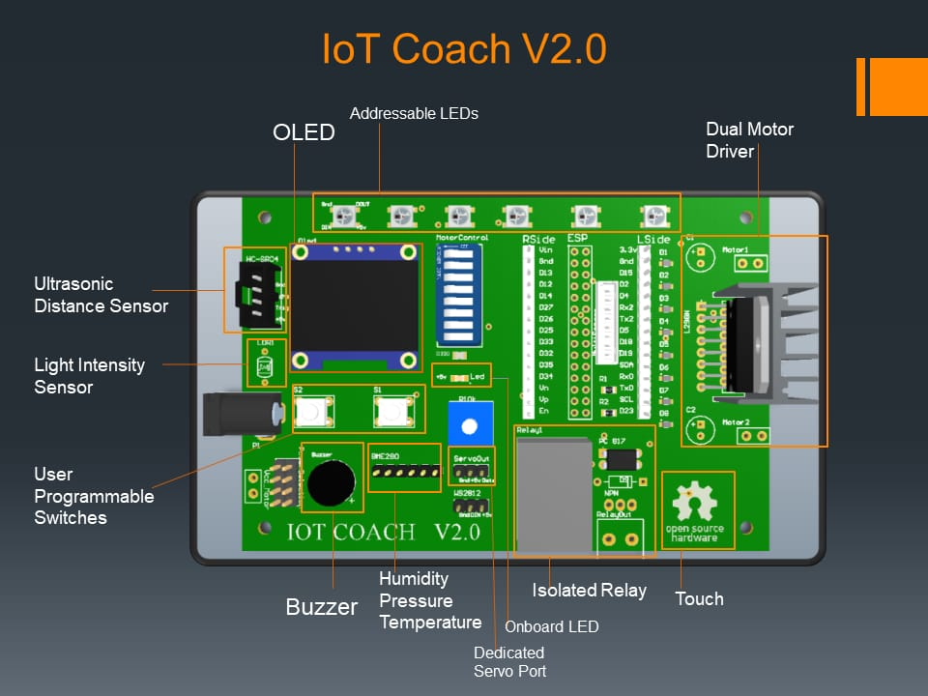

**Components of IoT Coach V2.0:**

1. **ESP 32:** It is the brain of this IoT kit is ESP Wroom 32. It is a is a powerful, generic Wi-Fi+BT+BLE MCU module that targets a wide variety of applications, ranging from low-power sensor networks to the most demanding tasks.

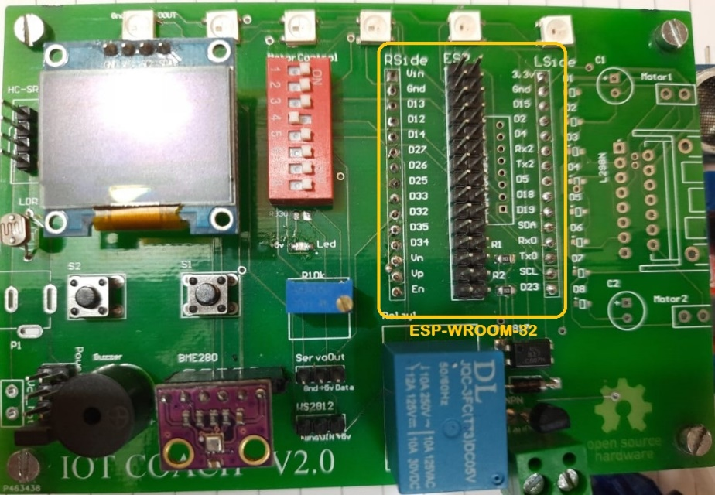

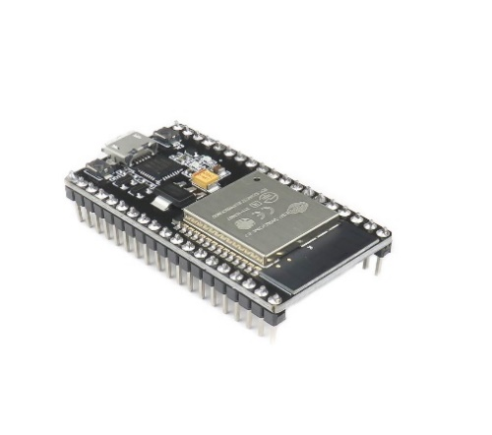

The ESP-WROOM-32 chip comes with 38 pins with multiple functions. Not all pins are exposed in all ESP32 development boards, and there are some pins that cannot be used.

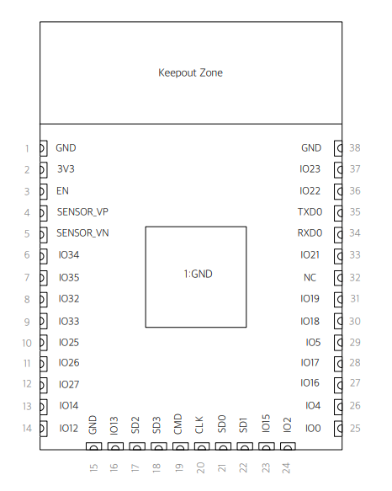

ESP32-WROOM-32 (ESP-WROOM-32) Pin layout

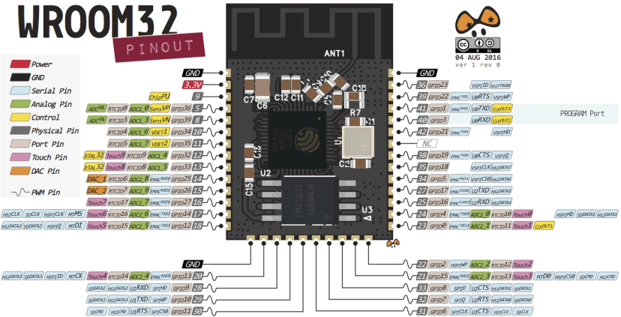

 ESP-WROOM-32 pinout

In this course we are using ESP-WROOM-32 which has 30 exposed pins.

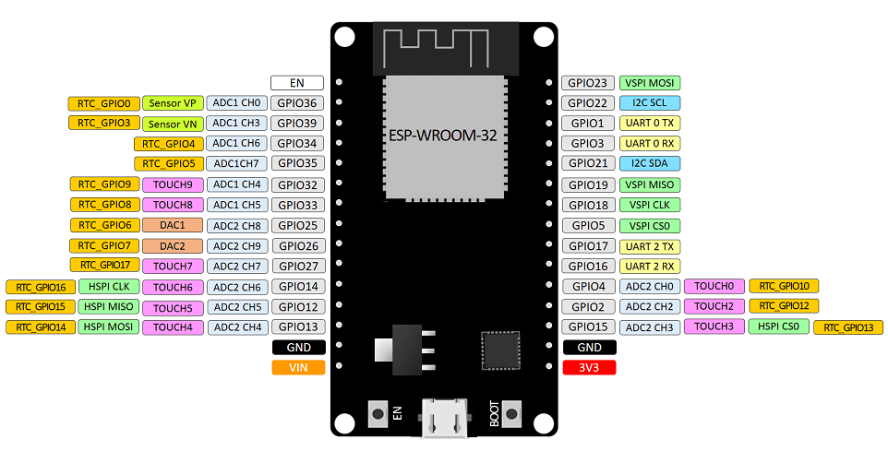

ESP Wroom32 Datasheet: <https://www.espressif.com/sites/default/files/documentation/esp32-wroom-32_datasheet_en.pdf> (have a look to know more about esp-wroom-32).

1. **OLED:** Various OLED panels are available in the market.

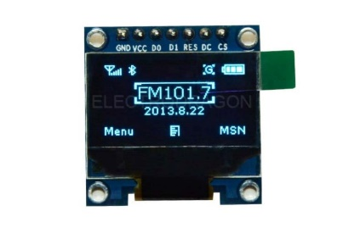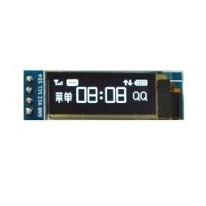 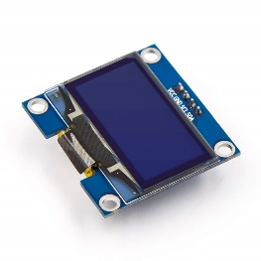

One used in this Kit is 128*64(pixels) I2C panel.

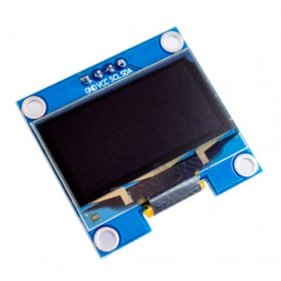

I2C 128X64 OLED SCREEN

**OLED Connections:**

* **VCC -> +3.3V**
* **GND -> ground**
* **SCL -> GPIO 22**
* **SDA -> GPIO 21**

1. **Photoresistor:** A photoresistor (also known as a light-dependent resistor, LDR, or photo-conductive cell) is a passive component that decreases resistance with respect to receiving luminosity (light) on the component's sensitive surface.

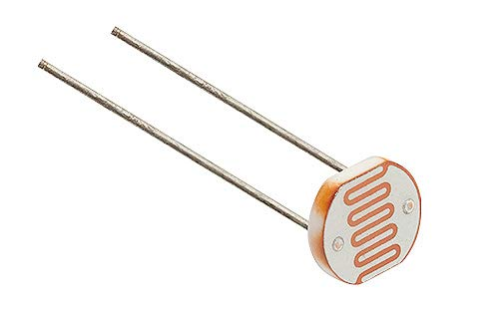 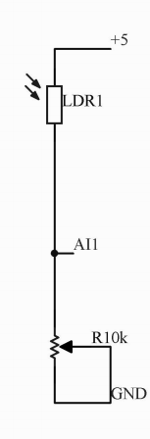

A photoresistor

**Photoresistor connections:**

* **VCC -> 5V**
* **GND -> Variable Resistance 10k**
* **AI1 -> Sensor VP / GPIO 36**

1. **Potentiometer:** A potentiometer is a three-terminal resistor with a sliding or rotating contact that forms an adjustable voltage divider. If only two terminals are used, one end and the wiper, it acts as a variable resistor or rheostat.

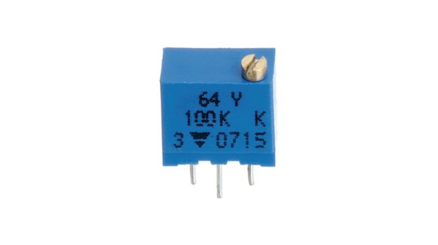

Potentiometer

**Potentiometer connections:**

**A potentiometer has 3 pins. Two terminals (the blue and green) are connected to a resistive element and the third terminal (the black one) is connected to an adjustable wiper.**

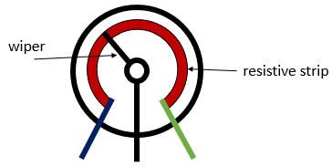

1. **HCSR04:** Ultrasonic Sensor HC-SR04 is a sensor that can measure **distance**. It emits an **ultrasound**at **40 000 Hz (40kHz)** which travels through the air and if there is an object or obstacle on its path It will bounce back to the module. Considering the travel time and the speed of the sound you can calculate the distance.

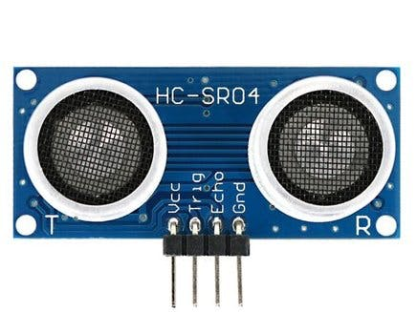

HC-SR04

**Ultrasonic connections:**

* **VCC -> 5V**
* **Trig -> GPIO 13**
* **Echo -> GPIO 12**
* **GND -> GND**

1. **BME280:** The BME280 sensor module reads barometric pressure, temperature, and humidity. Because pressure changes with altitude, you can also estimate altitude. There are several versions of this sensor module. The BME280 sensor uses I2C or SPI communication protocol to exchange data with a microcontroller. BME280 sensor used in this kit works on I2C communication.

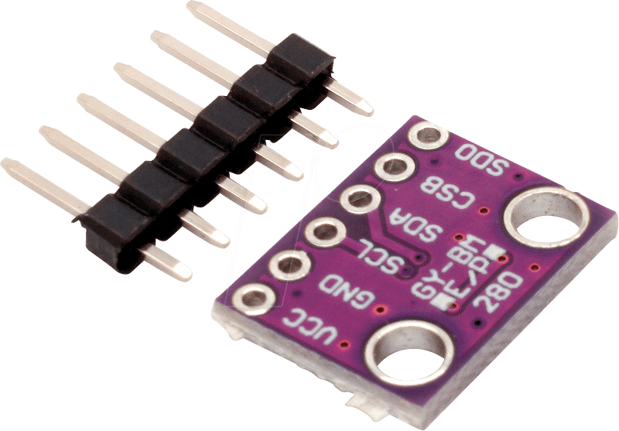

BME280

**BME280 Connections:**

* **VCC -> +3.3V**
* **GND -> ground**
* **SCL -> GPIO 22**
* **SDA -> GPIO 21**

1. **WS2812:** WS2812 is an intelligent control LED light source that the control circuit and RGB chip are integrated in a package of 5050 components. It internal include intelligent digital port data latch and signal reshaping amplification drive circuit. Also include a precision internal oscillator and a 12V voltage programmable constant current control part, effectively ensuring the pixel point light colour height consistent.

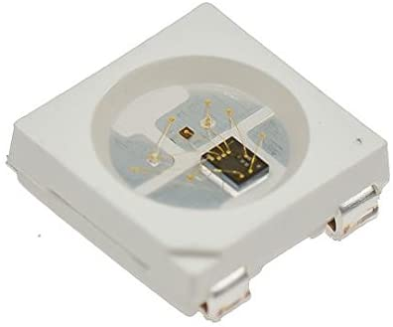

WS2812

**WS2812 Connections:**

* **VCC -> +5V**
* **GND -> ground**
* **WS2812DIN -> GPIO 33**

1. **Relay:** A Relay is an electromechanical device that can be used to make or break an electrical connection. It consists of a flexible moving mechanical part which can be controlled electronically through an electromagnet, basically, a relay is just like a mechanical switch but you can control it with an electronic signal instead of manually turning it on or off.

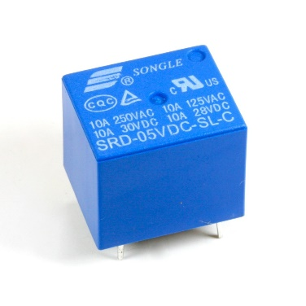

Relay

**Relay Connections:**

* **Relay Out -> GPIO 25**

.

1. **Capacitive Touch:** The ESP32 has capacitive touch GPIOs. These GPIOs can sense variations in anything that holds an electrical charge, like the human skin. So, they can detect variations induced when touching the GPIOs with a finger. These pins can be easily integrated into capacitive pads, and replace mechanical buttons

**Connection:**

* **GPIO 14**

1. **Programmable Switches:** The pushbutton is a component that connects two points in a circuit when you press it. Kit features two push buttons that can be programmed to do multiple tasks.

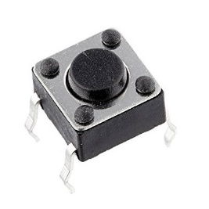

Switch

Kit features two push buttons which can be used as programmable switches.

**Switch connections**

* **Switch 1-> GPIO35**
* **Switch 1-> GPIO34**

1. **On board LED:** A **light-emitting diode** (**LED**) is a semiconductor light source that emits light when current flows through it. Electrons in the semiconductor recombine with electron holes, releasing energy in the form of photons. The colour of the light (corresponding to the energy of the photons) is determined by the energy required for electrons to cross the band gap of the semiconductor. White light is obtained by using multiple semiconductors or a layer of light-emitting phosphor on the semiconductor device.

* **Kit features on board led which is connected to GPIO 2**

1. **Servo:** A servomotor is a rotary actuator or linear actuator that allows for precise control of angular or linear position, velocity and acceleration. It consists of a suitable motor coupled to a sensor for position feedback. It also requires a relatively sophisticated controller, often a dedicated module designed specifically for use with servomotors.

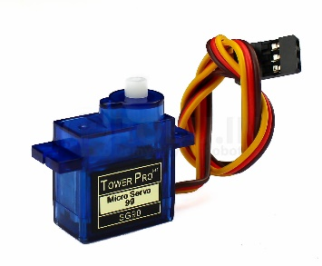

Servo

**Servo Connections:**

* **VCC -> +5V**
* **GND -> ground**
* **Servo Out -> GPIO 32**

1. **L298N Motor Driver:** L298N 2A Based Motor Driver is a high-power motor driver perfect for driving DC Motors and stepper motor. It uses the popular L298 motor driver IC and has an onboard 5V regulator which it can supply to an external circuit. It can control up to 4 DC motors, or 2 DC motors with directional and speed control.

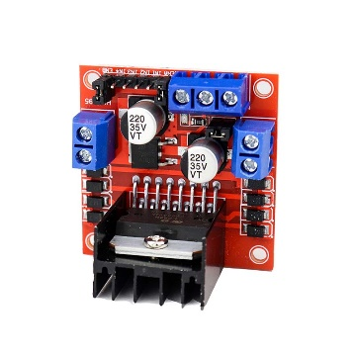

L298N

**Motor Driver Connections:**

* **IN1:**Input 1 for Motor A **-> GPIO15**
* **IN2**: Input 2 for Motor A **-> GPIO26**
* **IN3**: Input 1 for Motor B **-> GPIO5**
* **IN4**: Input 2 for Motor B **-> GPIO18**
* **ENA**: Enable pin for Motor A **-> GPIO4**
* **ENB**: Enable pin for Motor B **-> GPIO19**

1. **Buzzer:** Piezo buzzers are simple devices that can generate basic beeps and tones.  They work by using a piezo crystal, a special material that changes shape when voltage is applied to it.  If the crystal pushes against a diaphragm, like a tiny speaker cone, it can generate a pressure wave which the human ear picks up as sound.  Simple change the frequency of the voltage sent to the piezo and it will start generating sounds by changing shape very quickly.

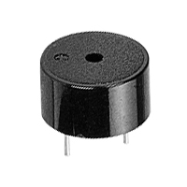

* **Connected to GPIO 27**

**Programming Environment:**

**Arduino IDE:** We will program our ESP-32 with Arduino development environment.

**Download and Install Arduino IDE:**

* [**https://www.arduino.cc/en/software**](https://www.arduino.cc/en/software) **[Follow this link to Download IDE]**
* [**https://www.arduino.cc/en/Guide**](https://www.arduino.cc/en/Guide) **[Follow this link for installation instructions]**

**Installing ESP32 Board in Arduino IDE:**

**To install the ESP32 board in your Arduino IDE, follow these next instructions:**

1. **In your Arduino IDE, go to File> Preferences**

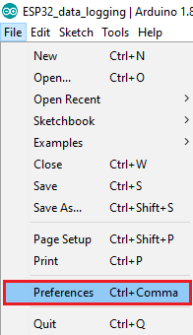

1. **Enter**[**https://dl.espressif.com/dl/package_esp32_index.json**](https://dl.espressif.com/dl/package_esp32_index.json) **into the “Additional Board Manager URLs” field as shown in the figure below. Then, click the “OK” button:**

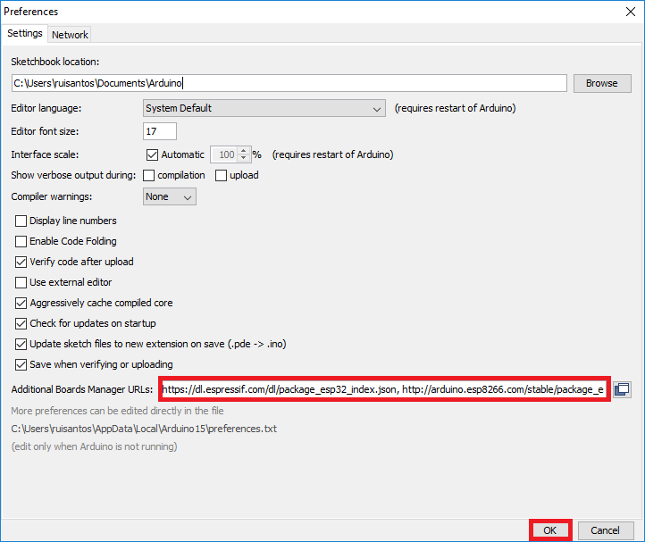

**Note:** if you already have the ESP8266 boards URL, you can separate the URLs with a comma as follows:

**https://dl.espressif.com/dl/package_esp32_index.json,http://arduino.esp8266.com/stable/package_esp8266com_index.json**

1. **Open the Boards Manager. Go to Tools > Board > Boards Manager…**

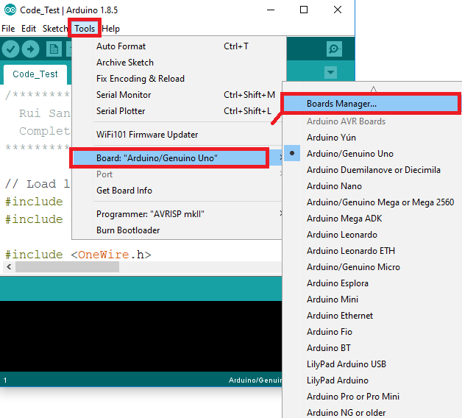

1. **Search for ESP32 and press install button for the “ESP32 by Espressif Systems “:**

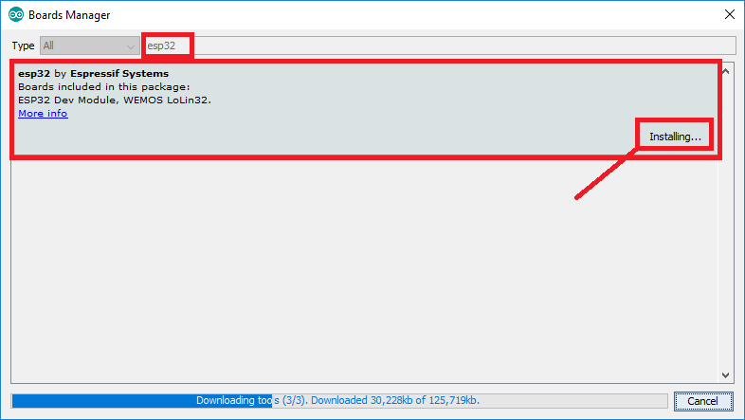

1. **That’s it. It should be installed after a few seconds.**

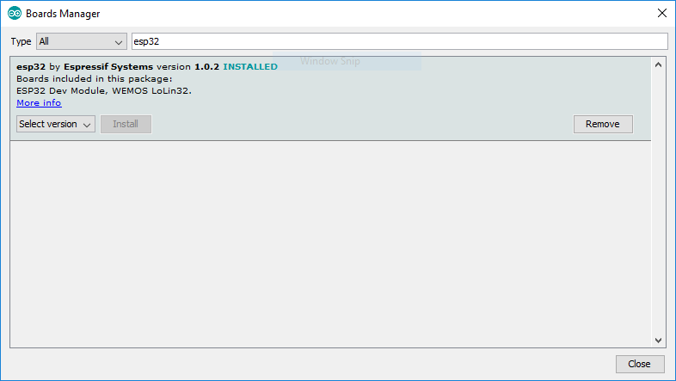

**First Program:**

**Blinking LED:** Simple program to Blink led with ESP-32

**Hardware required:**

* **ESP-32**
* **Breadboard**
* **220-ohm Resistor**

**Software required:**

* **Arduino IDE**
* **ESP-32 Board in Arduino IDE**

**What you will learn in this session:**

* Functions at start-up. **[ setup(), loop() ]**
* Functions for using GPIO [**pinMode(pin,mode),** **digitalWrite(pin,value)**]